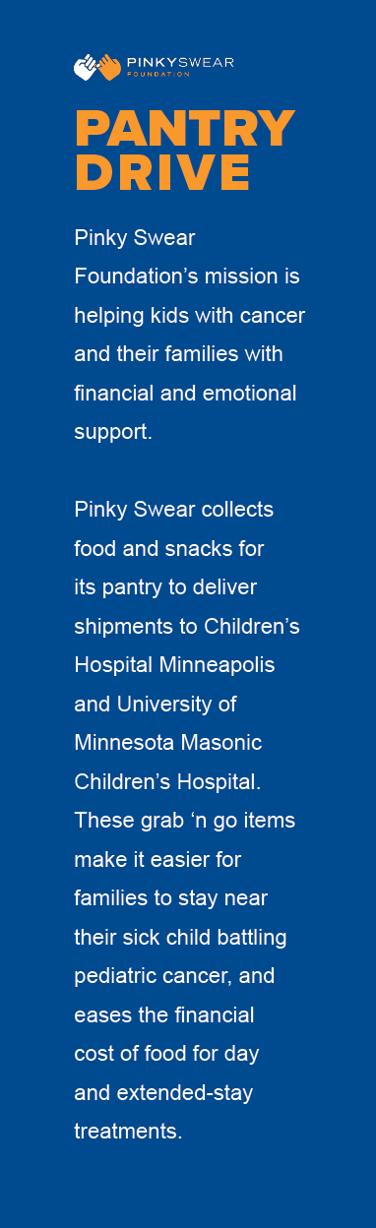
YOUR REASON FOR DOING A PANTRY DRIVE

We’re collecting non-perishable, individually portioned and wrapped food items. Items collected include:

• Easy Mac bowls
• Microwavable bowl meals
• Microwavable noodle bowls
• Microwavable soup bowls
• Oatmeal bowls
• Applesauce pouches
• Fruit cups
• Beef jerky
• Snack-size Chips/pretzels/crackers/cookies
• Fruit snacks
• Granola bars
• Microwave popcorn
• Pudding cups
• 12 oz Gatorade
• Crystal Lite/Hot cocoa pouches
• Individually wrapped tea bags
• Juice boxes
• Coffee K-cups
• Trail mix or nut packs

Donate now through Date

Please purchase off this Amazon Wish list, and the food will be shipped directly to Pinky Swear’s office.

Amazon Wish List Link

ANY OTHER PERSONAL NOTE/CONTACT INFO

